**ADD a COLUMN with ALTER TABLE**

Oops! We forgot to add the university_shortname column to the professors table. You've probably already noticed:

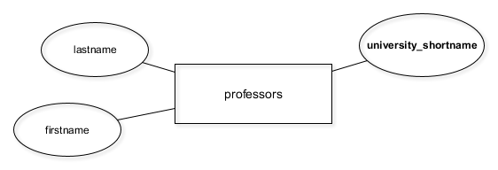

In chapter 4 of this course, you'll need this column for connecting the professors table with the universities table.

However, adding columns to existing tables is easy, especially if they're still empty.

To add columns you can use the following SQL query:

ALTER TABLE table_name

ADD COLUMN column_name data_type;

# RENAME and DROP COLUMNs in affiliations

As mentioned in the video, the still empty affiliations table has some flaws. In this exercise, you'll correct them as outlined in the video.

You'll use the following queries:

* To rename columns:

ALTER TABLE table_name

RENAME COLUMN old_name TO new_name;

* To delete columns:

ALTER TABLE table_name

DROP COLUMN column_name;

# Migrate data with INSERT INTO SELECT DISTINCT

Now it's finally time to migrate the data into the new tables. You'll use the following pattern:

INSERT INTO ...

SELECT DISTINCT ...

FROM ...;

It can be broken up into two parts:

First part:

SELECT DISTINCT column_name1, column_name2, ...

FROM table_a;

This selects all distinct values in table table_a – nothing new for you.

Second part:

INSERT INTO table_b ...;

Take this part and append it to the first, so it inserts all distinct rows from table_a into table_b.

**One last thing**: It is important that you run all of the code at the same time once you have filled out the blanks.